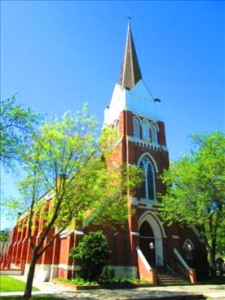

**Our Lady of Lourdes Parish**

345 Oak St **(Church)**

745 Ware Ave **(Office)**

Colusa, California 95932

**St. Joseph’ Mission (OFFICE) Divine Mercy Chapel Our Lady of Sorrows**

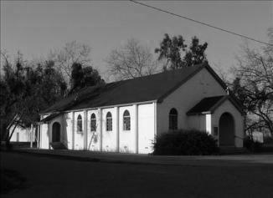 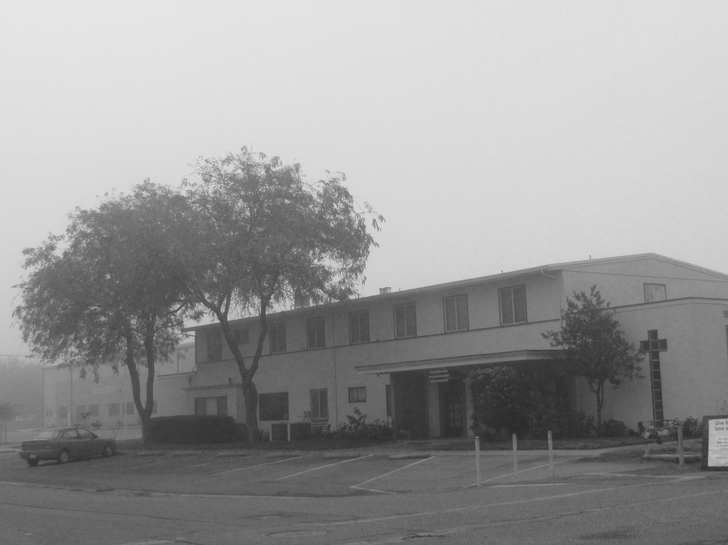 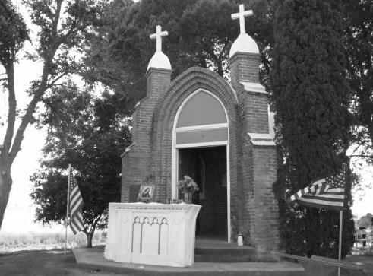

|  |  |  |
| --- | --- | --- |
| **Pastor:** Fr. Jacobo Caceres | Parish Office ***(mailing address):***  745 Ware Avenue, Colusa CA 95932 | **Principal:** Ramon Silva |
| **Deacon:** Ruben Fuentes  **Deacon:** Dr. Julian Delgado | Telephone: (530) 458-4170  **PARISH OFFICE HOURS**  **Hours:** 9:00 AM – 4:00 PM: Tuesday-Friday **Closed: Mondays**  **Parish Secretary/Bookkeeper:** Carmen Reyes | Our Lady of Lourdes School |
| **Parish Email:** [**ollcolusa@yahoo.com**](mailto:ollcolusa@yahoo.com) | 741 Ware Avenue, Colusa CA 95932 |
| **Website:** [**www.ourladyoflourdescolusa.com**](http://www.ourladyoflourdescolusa.com) | Telephone: (530) 458-8208  **Website:** [**www.theollschool.com**](http://www.theollschool.com) |

|  |  |  |  |  |  |  |  |  |  |  |  |  |  |  |  |  |  |  |  |  |  |  |  |  |  |  |
| --- | --- | --- | --- | --- | --- | --- | --- | --- | --- | --- | --- | --- | --- | --- | --- | --- | --- | --- | --- | --- | --- | --- | --- | --- | --- | --- |
| **Mass Intentions:**  **Daily Mass**  **Saturday Vigil 01/28/2023**   |  |  | | --- | --- | | 5:00 PM | +John Zumwalt | | 7:00 PM |  |   **Sunday: 01/29/2023**   |  |  | | --- | --- | | 8:00 AM |  | | 10:00 AM: | + Ruben Reynoso, For a fast recovery for Joe Silva | | 12:00 PM: |  |   **Weekly Daily Mass**   |  |  | | --- | --- | | **Tues. 01/31:** | +Mary Harper | | **Wed. 02/01:** |  | | **Thurs. 02/02:** |  | | **Fri. 02/03:** | +Art "Gino" Genera |   **Weekend Mass Schedule**   |  |  | | --- | --- | | **Saturday Vigil:** | **Sunday:** | | 5:00 PM: English Mass  7:00 PM: Spanish Mass | 8:00 AM: Bilingual -St. Joseph (Princeton)  10:00 AM: English Mass  12:00 PM: Spanish Mass |   **Daily Mass Schedule:**  Tuesday: 7:30 AM **English Mass**  Wednesday: 6:00 PM **Spanish Mass**  Thursday: 9:00 AM **English School Mass at** St. Bernadette’s Hall;  6:00PM **Spanish Mass**  Friday:7:30 AM **English Mass**  **Eucharist Adoration:**  Monday: 5:00 PM-7:00PM  Tuesday: 5:00 PM-7:00 PM  Wednesday: 7:15 PM -8:00 PM  **Confession:**  Wednesday: 7:00 PM -8:00 PM  Friday: 7:00 PM -8:00 PM **only** on the ***1st Friday of the month***  **Or with an appointment.** | | | **Ministries**  **Religious Education:**  **Finance Council:** Brendan Farrell, Carmelita Silva  **Pastoral Council: (English):** Maryann La Grande, Deacon Dr. Julian Delgado, Mario Reyes, Rosie Garcia, and Clint Jewett. **(Spanish):** Candelaria Ostrom, Silvia Serrato, Lupita Pérez, Olga López, Rosa Pulido, Javier Sanchez, and Deacon Rubén Fuentes.  **Lectors & Eucharistic Ministers Coordinator:** Megan Farrell  **Music:**  English Choir: Gloria Delgado & Susan Walsh  Spanish Choir: Women’s Choir & Mario Reyes,  (Princeton): Mary Beth Massa  **Baptismal Prep Class:**  Rocio & Tony Meraz 530-458-4170  ***Next class:*** please call the office to sign up  **Care for the Sick:** Louise Woodring 530-458-2515  **Bible Study:**  **English:** Deacon Julian Delgado, Wednesdaysat 6:30 PM at St.  Bernadette’s Hall  **Spanish:** Deacon Ruben Fuentes, Tuesdays at 7:00PM at the hall next  to the church  **RCIA:**  **English-** Deacon Dr. Julian Delgado  **Spanish-** Fr. Jacobo; Thursdays: 7:00pm- 8:30 pm at the hall next to the  church  **Our Lady of Lourdes Museum:** Louise Woodring 530-458-2515  Open by appointment only  **Catholic Ladies Relief Society:**  6:30 PM: 1st Wed. of the month St. Bernadette’s Hall (Fr. Doner’s room)  **Knights of Columbus:**  4th Tuesday of the month, dinner at 6:00 p.m.; meeting  7:00 p.m. at the hall next to the church  **Altar Server Coordinator:**  **Altar, Art and Environment:** Norma Ahumada  **Grief to God to Glory:** Valorie Ingerbretsen 530-701-7182, 1st Thursday of the month 7:00 PM- 8:30 PM, St. Bernadette’s Hall (Fr. Doner’s room) | |
| **January 29, 2023 – 4th Sunday in Ordinary Time** | | | | |
| ***PLEASE PRAY …***    ***… For those who are ill:***  Frank & Joan Hamill & family,  Sally Moore, Andrea Espindola, Carlos Plaza, Valeria Royal, Mary Unzueta, Leticia González, Jim White, Teresa Medina, Teresa Espindola, Bud Williams, Christian Munoz Silva, and Vernon Bisho,  … For those who are hospitalized or homebound: Carmelita Shely. Also, please keep Fr. Myles in your prayers.  If anyone needs Holy Communion or Prayers for Healing, please call Louise Woodring (530-458-2515) or Fr. Jacobo at (530-458-4170).  **… For the need of our parish and our catholic school.**  **Second Collection for the Month of January**  ~~31/01: Building and Maintenance~~  ~~07/08: Insurance & Assessment~~  ~~14/15: OLL School~~  ~~21/22: Retirement Fund for Religious~~  28/29: Church Restoration Fund  **Please make all second collection checks payable to Our Lady of Lourdes Church.**  **Choir Practice**  Choir practice every 2nd Tuesday of the month at 7:00 pm at the church.  **RCIA - Sacraments for Adults**  Does someone you know (an adult) still need to receive their Baptism, First Communion or Confirmation?  The Rite of Christian Initiation classes are for this purpose. They will start on **Thursday, February 2 at 6:30 PM** in the Parish Center.  (745 Ware Avenue). This class is open to adults that would like to learn more about the catholic faith.  **Collecting old palms for Ash Wednesday**  Our Lady of Lourdes Church will be collecting old palms to be burn and use the ashes for this year's Ash Wednesday. Please put them in the designated basket in the entrance of the church or bring them to parish office.  **This year Ash Wednesday will be February 22, 2023**  **KNIGHTS OF COLUMBUS-CRAB FEED**  "MEN ONLY"  TUESDAY, FEBRUARY 28, 2023  Social Hour: 6:00 p.m. • Dinner: 7:00 p.m.  St. Bernadette's Hall  745 Ware Avenue, Colusa Donation: $75.00  **Father Jacobo taking time off**  Father Jacobo will be gone from February 8-15.  Fr. Guillermo Hernandez Director of Vocations of the Dioceses of Sacramento is going to be covering the weekend Masses of the 11-12 of February.  **Potluck for Fr. Guillermo**  After the 12 PM Mass will have a potluck “brunch” for Fr. Guillermo. Come and meet Fr. Guillermo, he will be answering questions regarding vocations.  There will be no daily Mass during this time.  Fr. Victor from Sacred Heart Parish will be celebrating the School Mass on February 9 & 16 at **9:30 AM.**  **School Mass**  **Please note the following changes for the next week for school Mass:**  **No school Mass on Thursday, it will be move to Friday, February 03, 2023 at 9:00 AM.**  **Spam!**  **Please beware of spams! Fr. Jacobo nor any of the Deacons, office staff or past pastors of OLL will request any type of financial help via text or email. Please be careful if you receive any of these.** | | | https://tse3.mm.bing.net/th?id=OIP.Made45af7d88ded55c5d202fd636dc04fo0&pid=15.1&P=0&w=342&h=102   |  |  |  | | --- | --- | --- | | December | OLL Colusa | St. Joseph Mission | | 31/01: | $3,76 | $405 | | 07/08: | $3,070 | $400 | | 14/15: | $3,287 | $362 | | 21/22: | $3,599 | $388 | | 28//29: |  |  |   Month of January Special and Second Collections  31/01: Building and Maintenance: $1,706  07/08: Insurance & Assessment: $1,493  14/15: OLL School $1,157  21/22: Retirement Fund for Religious $1,471  28/29:  **Quinceañeras & Weddings**  To reserve a date, you have to book at least **9 months** in advance. Call the office for more information.  **Quinceañera Classes**  If your daughter is planning to have a Quinceañera this year, one of the requirements is to attended these classes.  **Next Class** will be on WEDNESDAY, February 1, 2023 at 5:30PM at the parish office. Please contact the office to sign up  **First Friday of the month Overnight Adoration**  **From Friday, February 03 at 7:00 PM to Saturday,**  **February 04 at 6:00 AM.**  The sign-up sheet is on a clip board at the entrance of the church.  There will be Spanish Mass on Friday, February 03 at 6:00 PM followed by Adoration and Fr. Jacobo will be hearing confessions after Mass.  **Our Lady of Lourdes School**  **World’s Finest Chocolates**  You can buy chocolates from Our Lady of Lourdes School’s families or at the school’s office.    **Save the date: Crab Feed, Saturday, March 18, 2023**  **Thank you for your support!**  **Theology of Body Workshop for Parents & Teens**  Friday, February 17, 2023, 6pm-8:30pm  St. John Vianney (10497 Coloma Rd. Rancho Cordova, CA 95670)  Join us! To explore God’s plan and for us to understanding what it means to be human and how to orient our lives and our actions toward authentic fulfillment. Parent’s workshop will cover the conversation about parenting and helping your child understand their body. Teen’s workshop will provide understand of God’s plan for each individual and will come away with a faith-filled vision of hope that will instill in you the sheer wonder and joy of being alive.  Cost: $20 per family  Register: www.scd.org/TOB2023  For more information, contact: Moises De Leon 916.733.0133 or email [MDeleon@scd.org](mailto:MDeleon@scd.org)  **Catholic Scouting College Service Scholarships Available**  The National Catholic Committee on Scouting (NCCS) is awarding ten service scholarships totaling $27,000. If you are a service oriented Catholic Scout, who is a high school senior, has received the Ad Altare Dei, Light is Life or Pope Pius XII award, and earned the Eagle Scout, Summit or Quartermaster Award you may qualify.  See the NCCS website: https://nccs-bsa.org/college-scholarships/ for complete eligibility requirements and the 2023 application.  NCCS Scholarship applications are due by March 1st each year. | |
| **Español** | | | | |
| **Iglesia Católica de Nuestra Señora de Lourdes**  **Correo electrónico:** [ollcolusa@yahoo.com](mailto:ollcolusa@yahoo.com)  **Sitio web:** [www.ourladyoflourdescolusa.com](http://www.ourladyoflourdescolusa.com)  345 Oak Street **(iglesia)**  **Correspondencia y oficina:**  745 Ware Ave. Colusa, CA 95932 | | | **Horario de oficina:**  9:00 AM- 4:00 PM: Martes a Viernes **Cerrado: los Lunes**  **Número de teléfono:** 530-458-4170  Confesiones:  6:50 PM a 8:00 PM: Miércoles  O con cita | |
| Misas Dominicales: | | Exposición del Santísimo Sacramento:  Lunes: 5:00 PM-7:00 PM  Martes: 5:00 PM-7:00 PM  Miércoles: 7:00 PM – 8:00 PM | | **Horario de Misas Diarias:**  Martes: 7:30 AM **inglés**  Miércoles: 6:00 PM **Español**  Jueves: 9:00 AM **Inglés**; **6:00PM Español**  Viernes: 7:30 AM **Inglés** |
| Vigilia del Sábado:  5:00PM: **Inglés**  7:00 PM: Español | Domingo:  8:00 AM: Bilingüe (Princeton)  10:00 AM: Ingles  12(medio día): Español |
| **Segunda Colecta para el Mes de Enero:**  **28/29: Fondo de Restauración de la Iglesia**  **Clase pre bautismal:** Próxima clase está programada para el **Viernes** 03, de Febrero a las 6:00 PM. Es necesario regístrate en la oficina parroquial para asistir a la clase.  **Bodas Y Quinceañeras**  Para reservar una fecha tienes que resérvala con **9 meses** de anticipación.  Comuníquese con la oficina para más información.  **Taller de Oración y Vida**  Se llevarán acabó los viernes a las 6:30 PM en el saloncito al lado de la iglesia. **¡Té esperamos!**  **Escuela Católica de Nuestra Señora de Lourdes**  **World’s Finest Chocolates (Los mejores chocolates del mundo)**  Las familias de la escuela de Nuestra Señora están vendiendo esto chocolates.    **Reserve la fecha: Crab Feed (Sena de cangrejo), sábado 18 de marzo de 2023.**  **¡Gracias por su apoyo!**  **Clase de catecismo para adulto (RICA)**  La clase para preparación para adultos que necesitan sus sacramentos reanudara el Jueves, 02 de Febrero a las 7:00PM. Esta clase se llevará a cabo en el saloncito parroquial al lado de la iglesia. Todos están invitados a participar.  **El Padre Jacobo tomara tiempo libre**  El padre Jacobo estará fuera del 8 al 15 de febrero.  El Padre Guillermo Hernández Director de Vocaciones de la Diócesis de Sacramento estará cubriendo las Misas del fin de semana del 11 al 12 de febrero.  **Comida compartida (de traje) para el Guillermo**  Después de la misa de las 12:00 PM habrá un “almuerzo-lonche” para el P. Guillermo. Ven y conoce al P. Guillermo, estará respondiendo preguntas sobre vocaciones.  No habrá misa diaria durante este tiempo.  Padre Víctor de la Parroquia del Sagrado Corazón estará celebrando la Misa de la escuela católica el **Jueves 9 y 16 de febrero a las 9:30 AM.** | | | **Primer viernes de mes Adoración nocturna**  Desde el viernes 03 de Febrero a las 7:00 PM hasta el sábado  07 de enero a las 6:00 AM.  La hoja de inscripción está en un tablón a la entrada de la iglesia.  Habrá misa en español el viernes 03 de Febrero a las 6:00 PM seguida de Adoración y el Padre Jacobo escuchará confesiones después de la Misa.  **Misa escolar**  Tenga en cuenta los siguientes cambios para la próxima semana para la misa escolar:  No hay misa escolar el jueves, se trasladará al viernes 03 de febrero de 2023 a las 9:00 AM.  **¡Correo no deseado! (Spam)**  Por favor, ¡cuidado con los correos no deseados! El Padre Jacobo ni ninguno de los diáconos, el personal de la oficina o los pastores anteriores de la Parroquia de Nuestra Señora de Lourdes solicitarán ningún tipo de ayuda financiera por mensaje de texto o correo electrónico. Tenga cuidado si recibe alguno de estos.  **Clases de Quinceañera**  Si tu hija está planeando tener una Quinceañera este año, uno de los requisitos es asistir a estas clases.  La próxima clase será el **MIÉRCOLES 1 de febrero de 2023 a las 5:30 p. m.** en la oficina parroquial. Comuníquese con la oficina para registrarse  **Cenáculo de la Divina Misericordia**  El Cenáculo de la Divina Misericordia se reúne todos los miércoles después de la Misa de 6:00pm en el salón al lado de la iglesia. Este es un grupo de oración donde reflejamos sobre la devoción a la Divina Misericordia y El Diario de Santa Faustina Kowalska. Todos son bienvenidos.  **Taller sobre la Teología del Cuerpo para Padres y Jóvenes**  Viernes, 17 de Febrero, 6pm – 8:30pm  St. John Vianney (10497 Coloma Rd. Rancho Cordova, CA 95670)  ¡Únete a nosotros! Explorar el plan de Dios y que entendamos qué significa ser humano y cómo orientar nuestra vida y nuestras acciones hacia la auténtica realización. El taller para padres cubrirá la conversación sobre la crianza de los hijos y cómo ayudar a su hijo a comprender su cuerpo. El taller para adolescentes proporcionará comprensión del plan de Dios para cada individuo y saldrá con una visión de esperanza llena de fe que inculcará en ti la maravilla y el gozo de estar vivo.  Costo: $20 por familia  Registrarse a: www.scd.org/TOB2023  ¿Preguntas? Contacte la Oficina de Familia y Respeto a la Vida: Moises De Leon 916.733.0133 or email [MDeleon@scd.org](mailto:MDeleon@scd.org)  **Libertad Religiosa y Responsabilidad de los Padres**  Este evento gratuito equipará a las personas de fe para participar respetuosamente en la plaza pública con convicciones religiosas demostradas de manera cautivadora y redentora. También tendrá la oportunidad de conocer a otros padres y líderes en los distritos escolares.  sábado 4 de marzo del 2023 de mediodia a 2:00 PM  Parroquia el Buen Pastor, 9539 Racquet Court, Elk Grove, CA 95758  Regístrese en: [www.scd.org/libertad](http://www.scd.org/libertad) 916-733-0133 | |
| Domingo, 29de Enero, 2023 – **4º Domingo Tiempo Ordinario** | | | | |

|  |  |  |
| --- | --- | --- |
| C:\Users\Our Lady of Lourdes\Downloads\20160516_081338.jpg |  |  |
|  |  |  |
|  |  |  |
| C:\Users\Our Lady of Lourdes\Downloads\20160518_080757 (1).jpg |  |  |
|  |  | |
|  |  | |