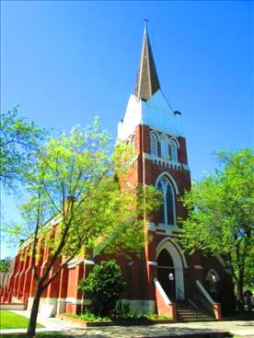

**Our Lady of Lourdes Parish**

345 Oak St **(Church)**

745 Ware Ave **(Office)**

Colusa, California 95932

**St. Joseph’ Mission Divine Mercy Chapel Our Lady of Sorrows**

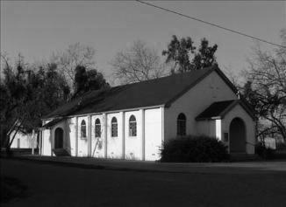 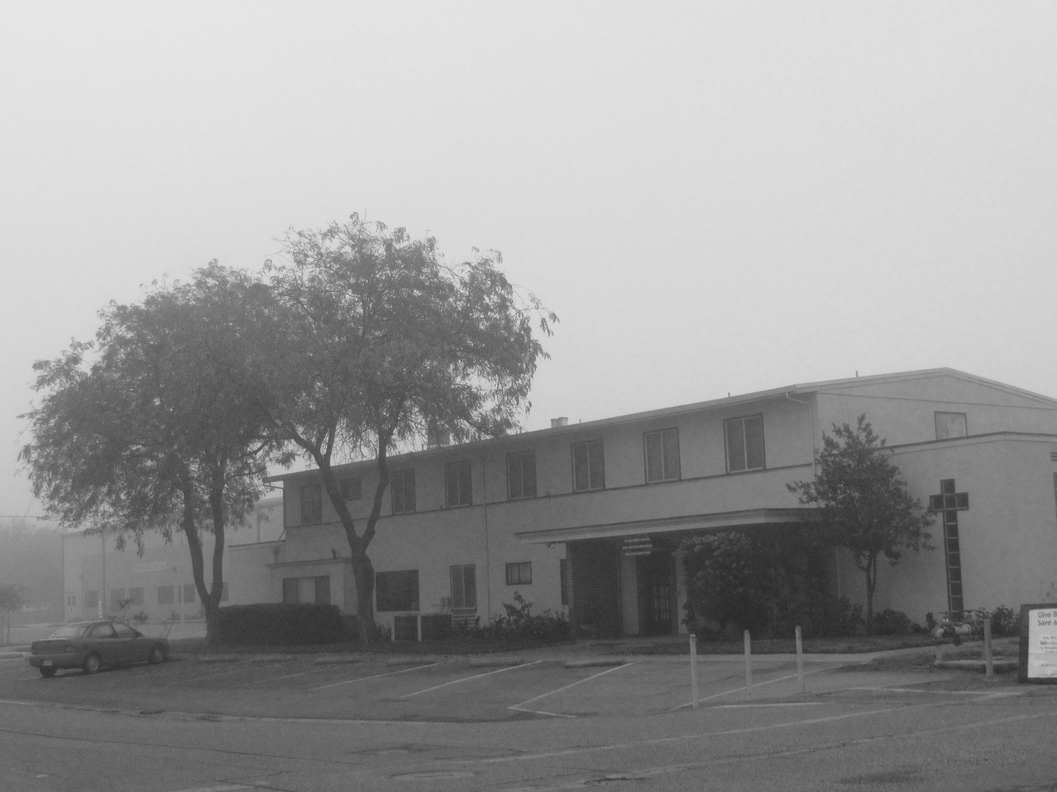 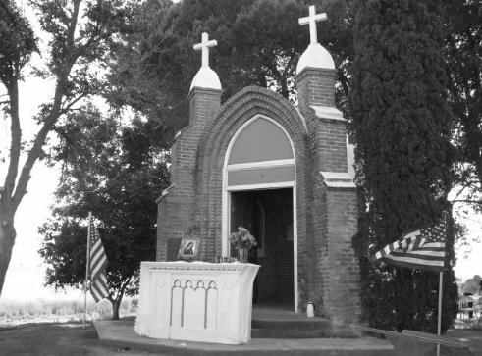

|  |  |  |
| --- | --- | --- |
| **Pastor:** Fr. Matthew Blank | **Deacon:** Ruben Fuentes | **Principal:** Ramon Silva |
| frmattblank@gmail.com | **Deacon:** Dr. Julian Delgado | Our Lady of Lourdes School |
| Parish Office: 745 Ware Avenue |  | 741 Ware Avenue, Colusa CA 95932 |
| Telephone: (530) 458-4170 |  | Telephone: (530) 458-8208 |
| **Website:** [**www.ourladyoflourdescolusa.com**](http://www.ourladyoflourdescolusa.com) | **Parish Email:** [**ollcolusa@yahoo.com**](mailto:ollcolusa@yahoo.com) | **Website:** [**www.theollschool.com**](http://www.theollschool.com) |

|  |  |  |  |  |  |  |  |  |  |  |  |  |  |  |  |  |  |  |  |  |  |  |  |  |  |  |  |  |  |
| --- | --- | --- | --- | --- | --- | --- | --- | --- | --- | --- | --- | --- | --- | --- | --- | --- | --- | --- | --- | --- | --- | --- | --- | --- | --- | --- | --- | --- | --- |
| **Mass Intentions:**  **Daily Mass**  **Saturday Vigil: 01/22/2022**   |  |  | | --- | --- | | **4:00 PM** | +Chris Steidlmayer | | **5:30 PM** | Cumpleaños de Mario Reyes |   **Sunday: 01/23/2022**   |  |  | | --- | --- | | **8:00 AM** |  | | **10:00 AM:** |  | | **12:00 PM:** |  |   **Weekly Daily Mass**   |  |  | | --- | --- | | **Mon. Jan 24:** |  | | **Tues. Jan 25:** |  | | **Wed. Jan 26:** | Lidia Hernández, Martin Méndez, **+**Keiry Vanessa Benitez | | **Thurs. Jan 27:** |  | | **Fri. Jan 28:** | Lidia Hernández, Martin Méndez,  **+**Jeannie Wilkinson, **+** Stephen Wilkinson, **+**Keiry Vanessa Benitez, | | **Sat. Jan 29:** |  |   **Mass Schedule**   |  |  | | --- | --- | | **Saturday Vigil:** | **Sunday:** | | 4:00 PM: English Mass  5:30 PM: Spanish Mass | 8:00 AM: English Mass  10:00 AM: Spanish Mass  12:00 PM: Bilingual -St. Joseph (Princeton) |   **Daily Mass:**  7:30 AM **English:** Monday, Tuesday, Thursday  6:30 PM **Spanish:** Wednesday & Friday  9:00 AM **English/Spanish on alternating weekends:**  First & Third Saturday: English  Second & Fourth Saturday: Spanish  Fifth Saturday: Bilingual  (Saturday daily Mass will only take place is there is no other events scheduled that day, we will keep you posted)  **Eucharist Adoration & Confession:**  Monday, Tuesday, Thursday: 5PM-7PM at the church  Wednesday & Friday: 7:15 PM -8:00 PM  Confession: During Adoration  Mondays: 5:00 PM- 5:45 PM,  Tuesday & Thursday: 5PM-7PM  Wednesday & Friday: 7:15 PM -8:00 PM  ***(If Fr. Matt is not in the confessional and is inside the church praying let him know you want to go to confession***)  **\*No confessions on Tuesdays** | | **PARISH OFFICE HOURS**  **Parish Secretary:** Carmen Reyes  9:00 AM – 4:00 PM: Monday, Wednesday, Thursday, Friday  **Closed: Tuesday**  **Ministries**  **Religious Education:** Dianne Luoma 530-632-7497  [dianneluoma@frontier.com](mailto:dianneluoma@frontier.com)  **Finance Council:** Brendan Farrell, Carmelita Silva,    **Lectors & Eucharistic Ministers Coordinator:** Megan Farrell  **Music:**  English Choir: Susan Walsh & Young Ladies (teen) Choir,  Spanish Choir: Young Ladies (teen) Choir, Women’s Choir & Mario Reyes (Princeton): Mary Beth Massa  **Baptismal Prep Class:**  Rocio & Tony Meraz 530-458-4170  Next class: Friday, January 28 at 6:00 PM, call the office to register.  **Care for the Sick:** Louise Woodring 530-458-2515  **Bible Study: Spanish:** Deacon Ruben Fuentes  **RCIA: English-** Deacon Dr. Julian Delgado & Fr. Matt  Wednesdays 6:30 p.m. -8:00 p.m. at the Parish Center  **Spanish-** Fr. Matt  Mondays 7:00pm- 8:30pm at the hall next to the church  **Our Lady of Lourdes Museum:** Louise Woodring 530-458-2515 Open by appointment  **Catholic Ladies Relief Society:**  To be announce  **Knights of Columbus:**  4th Tuesday of the month, dinner at 6:00 p.m.; meeting  7:00 p.m. at the hall next to the church  **Altar Server Coordinator:**  **Altar, Art and Environment:** Norma Ahumada  **Golden Pheasant Committee:**  **Pastoral Council: (English):** Maryann La Grande, Deacon Dr. Julian Delgado, Mario Reyes, Chuck Luoma, Rosie Garcia, and Clint Jewett. **(Spanish):** Candelaria Ostrom, Silvia Serrato, Lupita Pérez, Olga López, Rosa Pulido, Javier Sanchez, and Deacon Rubén Fuentes | |
| **January 23, 2022 ~ 3rd Sunday in Ordinary Time** | | | |
| ***PLEASE PRAY …***    ***… For those who are ill:***  Sally Moore,  Carlos Plaza, Valeria Royal, Mary Unzueta, Leticia González, Jim White, Teresa Medina, Teresa Espindola, Karla and Bud Williams, Christian Munoz Silva, and Vernon Bisho,  … For those who are hospitalized or homebound: Lila Lee Sankey & Carmelita Shely. Also, please keep Fr. Myles in your prayers.  If anyone needs Holy Communion or Prayers for Healing, please call Louise Woodring (530-458-2515) or Fr. Matt (530-458-4170).  **… For the need of our parish and our catholic school, especially during this COVID -19 Pandemic.**  **Second Collection for the Month of January**  ~~02: Building & Maintenance~~  ~~08/09: Insurance & Assessment~~  ~~15/16: OLL School~~  22/23: Repair the roof at the Rectory (Fr.’s House)  29/30: Repair the roof at the Rectory (Fr.’s House)  ***\*Please make all second collection’s checks payable to Our Lady of Lourdes Church.***  **Bible Study**  Wednesday evenings at 6:30PM at St. Bernadette’s Hall. This class in being given by Deacon Julian Delgado.  **Mark your calendar:**   * Thursday, February 03, St. Blaise: Blessing of the throats * Friday, February 11, Our Lady of Lourdes Feast Day: Mass & Potluck at 6:30PM * Saturday, February 26, OLL School: Crab feed   **Non-perishable Goods for An Emergency**  Parish office is collecting canned food for storage for emergencies. Please bring your donations during office hours.  **Our Lady of Lourdes School**  **Open House, please join us!**  Our Lady of Lourdes Catholic School - Preschool - 8th, welcomes you and your family to our Open House on Sunday, January 30th, 2022, 12:00pm - 2:00pm  Please join our community for Mass Saturday February 5th at 4:00pm to close Catholic Schools Week.  *Committed to Excellence In*  *Faith - Academics - Service*  For more information please call (530) 458-8208 or visit us on the web at: [theollschool.com](http://theollschool.com)  **World’s Finest Chocolates**  You can buy chocolates from Our Lady of Lourdes School’s families or at the school’s office.    **Thank you for your support!** | | https://tse3.mm.bing.net/th?id=OIP.Made45af7d88ded55c5d202fd636dc04fo0&pid=15.1&P=0&w=342&h=102   |  |  |  |  | | --- | --- | --- | --- | | Target Offertory | (Budget) | OLL Colusa | St. Joseph Mission | | Jan. 02 | $4,023 | $1,817 | $128 | | Jan 08/09: | $4,023 | 2,709 | 78 | | Jan 15/16: | $4,023 |  |  | | Jan 22/23: | $4,023 |  |  | | Jan 29/30: | $4,023 |  |  |   Month of January: Special and Second Collections  01: Mary, the Holy Mother of God: $1,142  02: Building & Maintenance: $687  08/09: Insurance & Assessment: $1,023.50  15/16: OLL School:  22/23: Repair the roof at the Rectory (Fr.’s House):  29/30: Repair the roof at the Rectory (Fr.’s House):  **World Marriage Day 2022**  Saturday, February 12, 2022 • 9:30am Mass with Bishop Jaime Soto  St Lawrence The Martyr Parish • 4325 Don Julio Blvd., North Highlands 95660  Join us as we honor marriage and salute the beauty of faithfulness, sacrifice, and joy in married life. During this live-streamed Mass, there will be a special blessing for sacramentally married couples and an opportunity for them to renew their marital commitment.  After Mass, there will be an opportunity to receive a blessing and picture with Bishop Soto. Special certificates will be distributed at the reception honoring couples celebrating milestone anniversaries (10, 25, 30, 35, 40, 45, 50, 50+).  If you plan to attend, please register at: www.scd.org/wmd  If you have questions, call the Office of Family and Faith Formation at (916) 733-0133  **World Day for Consecrated Life**  World Day for Consecrated Life will be celebrated in the Church on Wednesday, February 2, 2022 and in parishes over the weekend of February 5-6, 2022. Please pray for all those who have made commitments in the consecrated life, and be sure to thank them on their special day. May they continue to be inspired by Jesus Christ and respond generously to God's gift of their vocation.  **Discernment Retreat/St. Patrick’s Seminary February 25-27, 2022**  Are you being called to the priesthood? We invite you to respond to God’s invitation to hear His voice and give yourself the opportunity to discern your vocation. Who can attend this retreat? Young adult men age 21 or over who have seriously considered the priesthood as their possible vocation. How can I register? You can contact the Office of Vocations for more information at (916) 733-0258 and/or have your pastor send an email recommending your participation to msmith@scd.org. | |
| **January 23, 2022 ~ 3rd Sunday in Ordinary Time** | | | |
| **Español** | | | |
| **Iglesia Católica de Nuestra Señora de Lourdes**  **Correo electrónico:** [ollcolusa@yahoo.com](mailto:ollcolusa@yahoo.com)  **Sitio web:** [www.ourladyoflourdescolusa.com](http://www.ourladyoflourdescolusa.com)  345 Oak Street **(iglesia)**  745 Ware Ave. Colusa, CA 95932 **(oficina)** | | **Horario de oficina:**  9:00 AM- 4:00 PM: Lunes, Miércoles, Jueves, Viernes  **Cerrado: Martes**  **Número de teléfono:** 530-458-4170 | |
| Misas diarias entere semana:  6:30 PM: Miércoles y Viernes en español  9:00 AM: Sábado (segundo y cuarto sábado en español) | Exposición del Santísimo Sacramento:  5:00 PM-7:00 PM: Lunes, Martes, y Jueves  7:15 PM: Miércoles y Viernes | | Confesión:  Durante la Adoración. Tome en cuenta los Martes no hay confesiones. *(\* si el P. Matt no está en el confesionario y está dentro de la iglesia rezando, manteniendo la distancia de 6 pies, hágale saber que quiere ir a confesarse).* |
| Domingo, 23 de Enero, 2022 ~ **3º Domingo en Tiempo Ordinario** | | | |
| **Segunda Colecta para el Mes de Enero:**  15/16: Escuela Católica  **Productos no perecederos para una emergencia**  La oficina parroquial está recolectando alimentos enlatados para almacenarlos en caso de emergencia. Por favor traiga sus donaciones durante el horario de oficina.  **Clases de Catecismo Para Adultos en Español**  La clase se lleva a cabo los Jueves de 7:00 PM a 8:30 PM. En el saloncito al lado de la iglesia. Esta clase en dada por el Padre Matt.  **Marque su calendario:**  • Jueves 3 de febrero, Día de San Blas: Bendición de las gargantas  • **Viernes 11 de febrero, Fiesta de Nuestra Señora de Lourdes: Misa y comida de “traje” a las 6:30 PM**  • Sábado 26 de febrero, Escuela Católica: Cena de cangrejo  **Escuela Católica de Nuestra Señora de Lourdes**  **Casa Abierta “Open House”**  ¡Por favor acompáñenos!  La escuela Católica Our Lady of Lourdes - Preescolar - 8o, les da la bienvenida a usted y a su familia a nuestro “Open House” el domingo, 30 de enero de 2022, de 12:00pm a 2:00pm.  Únase a nuestra comunidad en la Misa del 5 de febrero a las 4:00 pm para cerrar La Semana de Escuelas Católicas.  *Comprometidos con la Excelencia En*  *Fe - Académicos - Servicio*  Para obtener más información llame al (530) 458-8208 o visítenos en: [theollschool.com](http://theollschool.com)  **Venta de Chocolates “World’s Finest Chocolate”**  Puede comprar chocolates de las familias de la escuela o en la oficina de la escuela.    **¡Gracias por tu apoyo!** | | **Para información de bautizos, bodas, o quinceañeras, por favor comuníquese a la oficina parroquial.**  **Clase pre bautismal:** Para la clase para el mes de Julio es necesario regístrate en la oficina parroquial para asistir a la clase. La clase esta programada para el **Viernes 28 de Enero a las 6:00PM**  **Cenáculo de la Divina Misericordia**  El Cenáculo de la Divina Misericordia se reúne todos los miércoles después de la Misa en el salón al lado de la iglesia. Este es un grupo de oración donde reflejamos sobre la devoción a la Divina Misericordia y El Diario de Santa Faustina Kowalska. Todos son bienvenidos.  **Día Mundial del Matrimonio-Renovación de Votos**  Sábado, 12 de Febrero del 2022, Misa a las 9:30am en St. Lawrence the Martyr Parish, North Highlands Únase a nosotros para honrar el matrimonio, la belleza de la fidelidad, sacrificio y la alegría en la vida matrimonial. Durante la transmisión en vivo de la misa, habrá una bendición especial para las parejas casadas sacramentalmente y la oportunidad de renovar su compromiso matrimonial.  Después de la misa, habrá la oportunidad para las parejas que reciban la bendición y foto con el Obispo Soto. En la recepción, se entregará un certificado especial a las parejas que celebran un aniversario significativo (10, 25, 30, 35, 40, 45, 50, 50+). Si está planeando asistir favor de inscribirse en: www.scd.org/wmd Si tiene alguna pregunta favor de llamar al Oficina de Familia y Formación en la Fe al (916) 733-0133.  **La Jornada Mundial para La Vida Consagrada**  La Jornada Mundial para La Vida Consagrada en la iglesia es el domingo, 2 de febrero del 2022 y en parroquias se celebrará el fin de semana del 5-6 de febrero del 2022. Favor de orar por quienes se han comprometido a la vida consagrada, y tomen esta oportunidad para darles las gracias en su día especial. Que continúen siendo inspirados por Jesucristo y respondan generosamente al regalo de su vocación que Dios les ha concedido. | |
| **January 23, 2022 ~ 3rd Sunday in Ordinary Time** | | | |

|  |  |  |  |
| --- | --- | --- | --- |
| C:\Users\Our Lady of Lourdes\Downloads\20160516_081338.jpg | |  |  |
|  | |  |  |
|  | |  |  |
| C:\Users\Our Lady of Lourdes\Downloads\20160518_080757 (1).jpg | |  |  |
|  |  | | |